**Ex1**

The Heisenberg principle states that the resolutions in time and in the frequency spaces must satisfy the relation 

-If the desired resolutionin the frequency space, what should be the sliding window width in the time space?

-We want to use this window to observe two cosines with frequencies f1=0.15 and f2=0.35 in the time-frequency space (STFT). Is this window good for observing these two signals without frequency overlapping?

**Ex2**

The first temptation to observe a signal in the time-frequency space, is to truncate the signal by a sliding window throughout the signal, and take the Fourier transform of each truncated signal, as shown in equation (1) in the case of a continuous STFT. To avoid redundancy, the truncation step (delay)  should be equal to the window width.



The STFT is applied to a signal composed of two cosines.

a)-Determine from each figure below,the frequency and the chronological order of the two signals.

b)- Knowing that the whole signal duration is N=1024, determine the truncated intervals number and the window duration (width) in each figure.

c) - In which figure the frequency resolution is good and why?

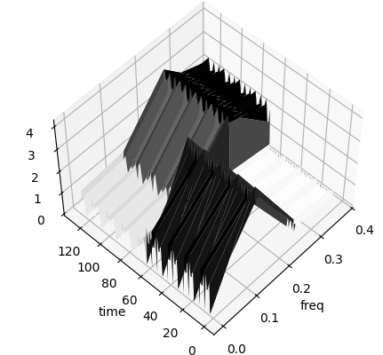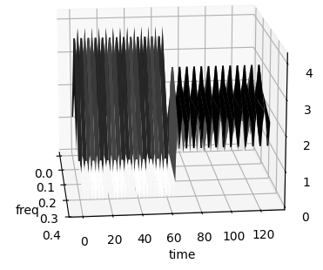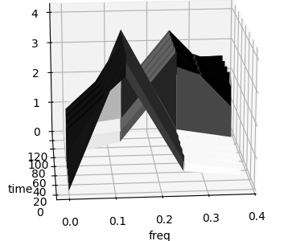

Fig.1

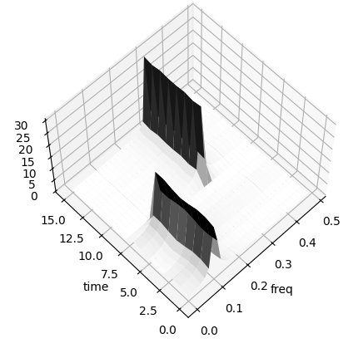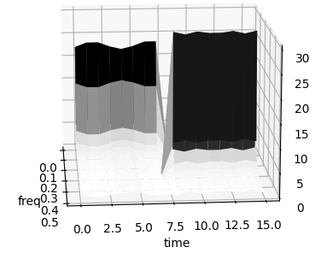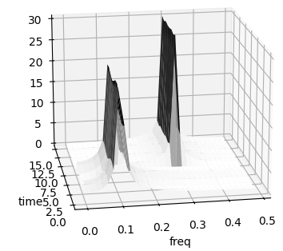

Fig.2

**Ex3**-Consider the digital rectangular signal defined by



1) –Determine its Fourier transform (FT). For which frequency values, does this FT vanish?

2)-The graph of this FT is given in the figure below.

a) - Determine from this graph the duration N of the digital rectangular signal

b) - Determine the main lobe width of this FT

c) - Determine the FIR band pass filter (central frequency and the pass band width B) that filters the 4th side lobe shown by the arrow.

